Jeremy Benik Progress and Accomplishments Fall 2021

**Introduction**

Over the course of the semester, I have worked on various tasks to help build my knowledge of how to use a supercomputer and how to code in python. This way, I can run experiments and cases to see how a fire propagates or how some variables change with time. At the beginning of the semester, I built and compiled WRF-SFIRE on my account on the cluster and ran some experiments to get a sense of how to use it. By running these test cases, I could then get a sense of what goes into running an experiment to use for future experiments.

One of the current experiments using WRF-SFIRE along with other models is the fireflux 2 experiment. The task at hand here is to verify the data in the experiment by running different models and plotting the data in python to see if the result from these different models will coincide with the original data. The goal of this is to see if by using the other models, if the fire propagation and other variables will still match up with observations. This will not only help verify the experiment, but test out the other model runs to see how well they perform with an idealized model.

**Tasks/Methodology**

With all the tasks I was given this semester (whether it be running an experiment or plotting data), there was a lot of learning to be done with them since I started out with just a basic knowledge of it.

* Learn how to better navigate a terminal
* Learn how to compile WRF-SFIRE to be used with experiments
* Learn how to run idealized experiments
* Learn how to run real experiments
* Understand the files necessary to run both kinds of cases
* Learn how to use the tool to view the output from running these experiments
* Use it for my future research projects

In terms of plotting tasks such as the fireflux 2 experiment, I have been using python and a little bit of excel to organize my data and create plots to view the data

* Excel
  + View the files and make any changes to them to make managing/plotting them easier in python
  + Make simple plots to verify the plots made in python
* Python
  + Truncating files to certain time intervals
    - Using these time intervals, I can average out the data and find a time average to use for the experiment
  + Calculations
    - Calculate wind speeds and wind direction
  + Loop through files
    - This will let me organize and plot many files at once
  + Plotting
    - Creating plots of the data to visualize it and see what was happening before, during, and after the fire front passage
      * Some of these plots include wind speeds, temperature vs. height, temperature vs time, etc.

**Accomplishments and discussion of your results**

One of the biggest accomplishments so far is how far I’ve come with python and using a cluster. Before this semester, I barely knew python and could somewhat navigate through a terminal and that was it. Now I feel much more confident with my programming skills and can do it much more easily. Here are some of my results from what I’ve learned with programming. These graphs will all pertain to the fireflux 2 project and I will discuss all of them. These codes and data can all be found on my github page I made specifically for research. Here is the link: <https://github.com/Jeremy-Benik/FireFlux2>

Main Tower Plots:

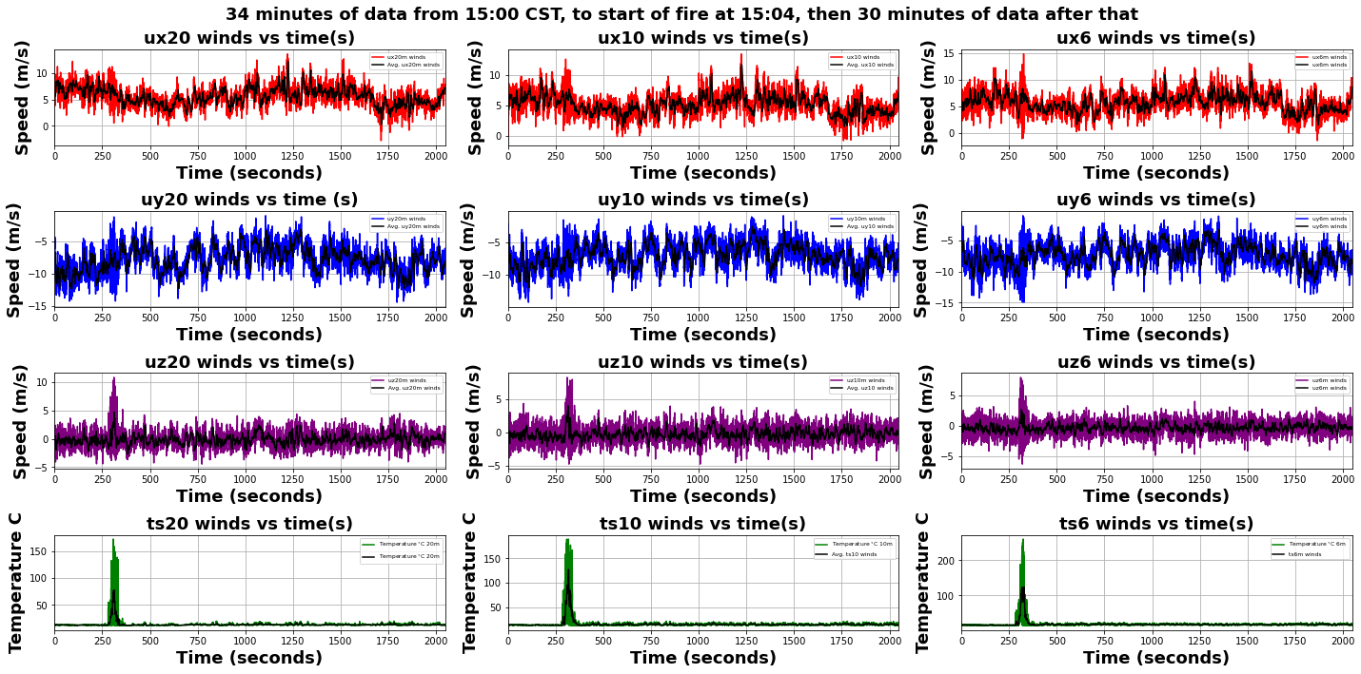

This plot was made by the code titled “Main_Tower_Plot_34min_All_Vars.py”. The path in the github is: FireFlux2/FireFlux2-main/Codes/Main_Tower_Codes/Main_Tower_Plot_34min_All_Vars.py

What this code does is it truncates a modified version of the main tower data (all that was done is moving some columns around since excel couldn’t import it properly) down to 34 minutes (4 minutes before ignition and 30 minutes after ignition), and then plots the data. There is also a rolling average plotted in the data to make sure there isn’t any large spike that could cause some unwanted bias in the data. With this plot, we can see when the fire front passed, and what variables changed as it passed through the tower. We have large increases in the temperature as the fire passes through the tower, which gives us an idea where to look in the other plots. Some good examples are the large increases in W wind as the fire passes through at all levels. Another interesting increase as the fire passes through is the 6 meter u wind speed. We can see there that there is a sharp increase as the fire passes. This is due to the inflow of air into the convective, low-level jet that’s being generated by the fire. This plot can be used to verify the model since it tells me where to look for fire front passage, and how the variables changed as the fire passed through the tower.

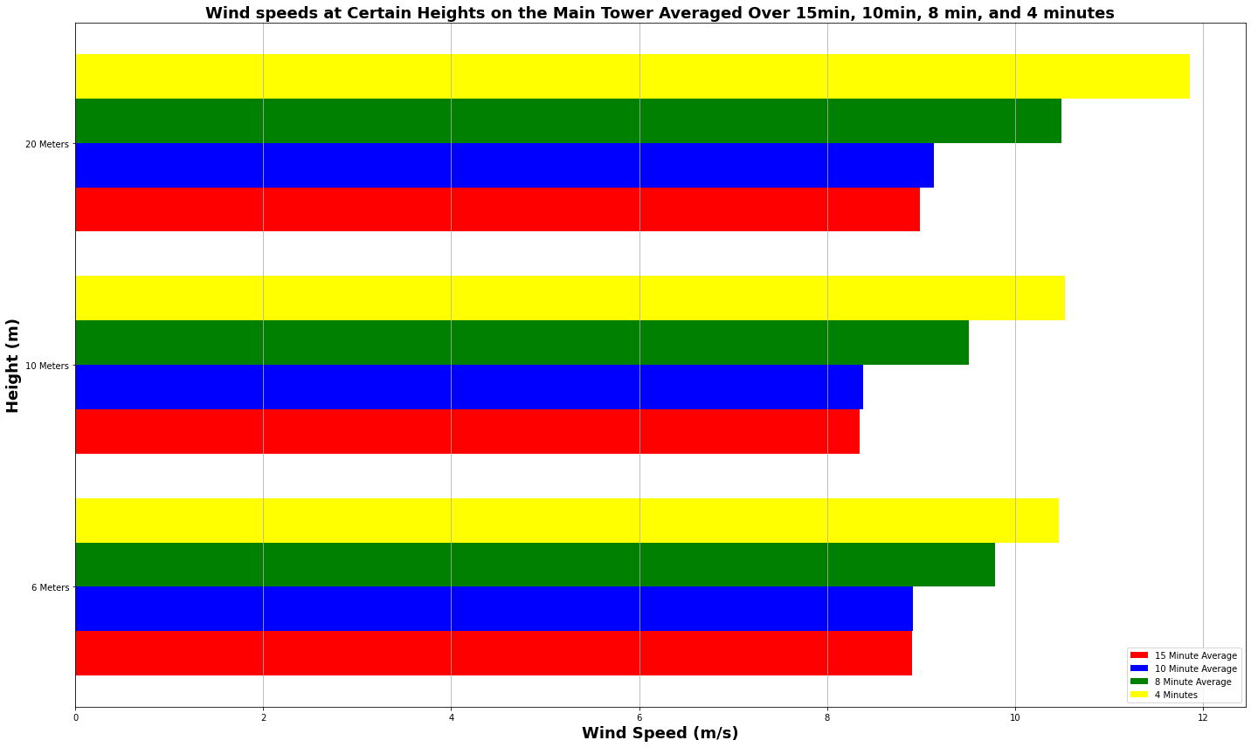

This bar plot was made using the code: Time_Averaged_Wind_Speed_Bar_Plot.py and can be found in the directory: FireFlux2/FireFlux2-main/Codes/Main_Tower_Codes/Time_Averaged_Wind_Speed_Bar_Plot.py

This plot time averages the calculated wind speeds (calculated from u and v) at the different height levels and plots them. The time averages were 4 minutes before ignition, 4 minutes before and 4 minutes after ignition (8 minutes total), 10 minutes after ignition, and 15 minutes after ignition to see what winds would represent the most ambient conditions to use in the input_sounding file. Since there are 3 different heights on the tower (6 meters, 10 meters, and 20 meters), the winds at all levels were averaged at these different times and plotted. We ended up going with the 4 minute time average since that seemed to represent the most ambient conditions to use.

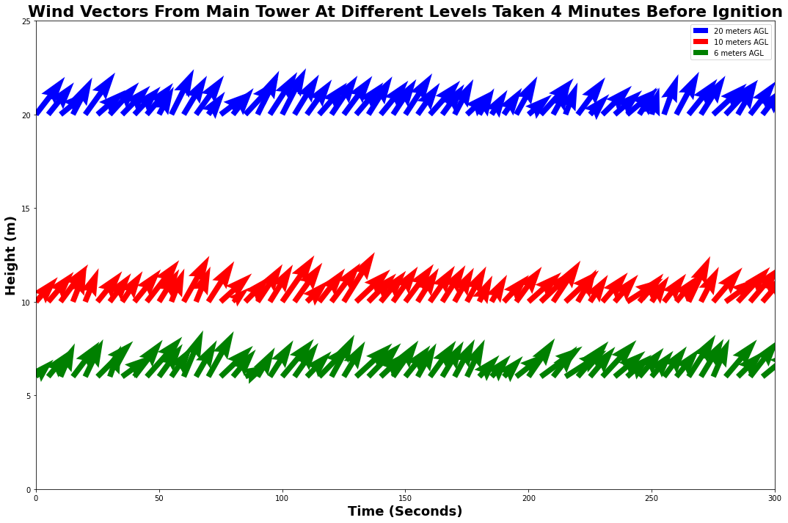

This plot was made using the code: Vector_Plot_Winds_Main_Tower.py and it is in the directory: FireFlux2/FireFlux2-main/Codes/Main_Tower_Codes/Vector_Plot_Winds_Main_Tower.py

This plot just shows the wind in vector form. The winds here are blowing towards the tower (imagine the tower is where the title is).

Short Tower Plots:

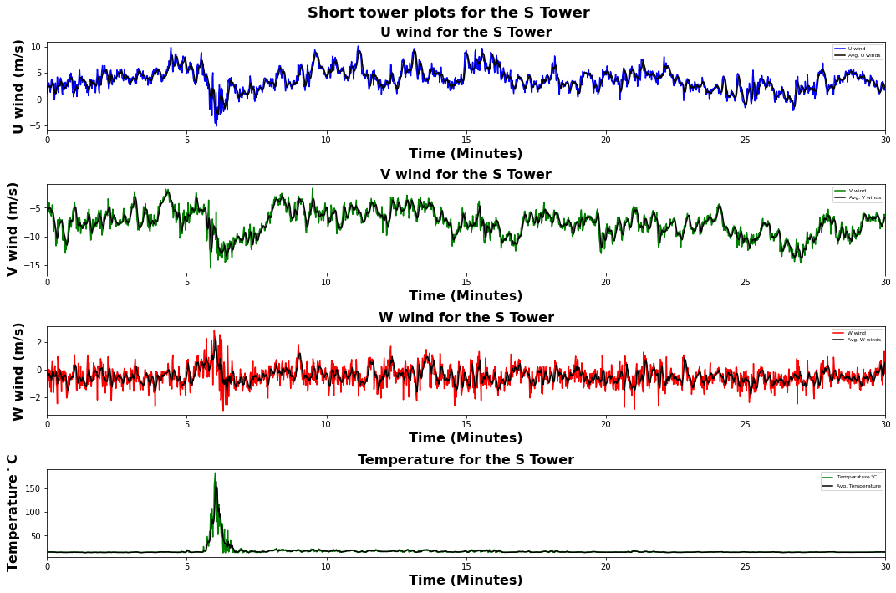

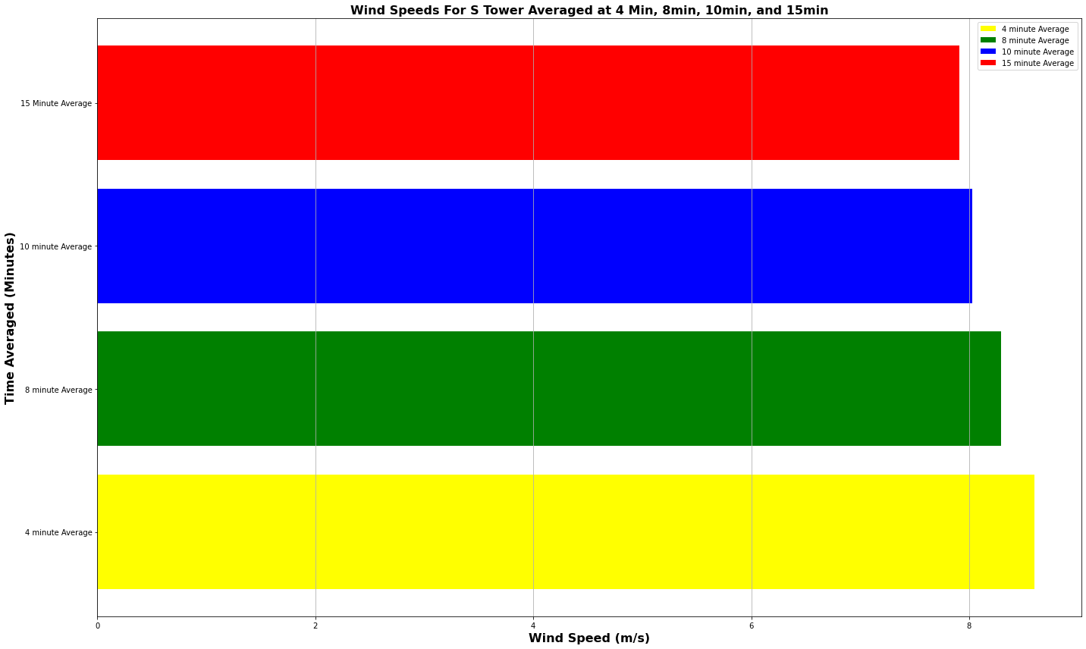

These two plots were made using the code: Short_Tower_Code.py and this code can be found in: FireFlux2/FireFlux2-main/Codes/Short_Tower_code/Short_Tower_Code.py

This code is similar to the Main Tower code above except this also plots a bar graph. The top plot titled Short tower plots for the S Tower is plotting all the variables from the South Tower. There were 3 towers in this experiment (West Tower, East Tower, and South Tower). This code goes through all the tower data and plots the data from the start of the fire at 15:04 CST to 15:34 CST. There is also a rolling average to reduce any possible bias. Like with the Main Tower plot, we can see when the fire passes through the tower. Then we can see how the winds and temperature change as it passes through. Such as with the U wind, there is a large increase in that again. This data was taken at 5.33m AGL since that is where the sensors were.

The bar graph plots a calculated wind speed (using u and v to calculate wind) and averages them out over different time intervals. The reason for doing this is to be able to see which time average of winds will yield the most ambient conditions to then use in the input_sounding file. The averages used here were 4 minutes before the ignition, 4 minutes before and 4 minutes after the ignition (8 minutes total), 10 minutes after ignition, and 15 minutes after ignition. In the end, we ended up using the 4 minute time average of the wind since that seemed to represent the most ambient conditions to use in the input_sounding.

Anemometers:

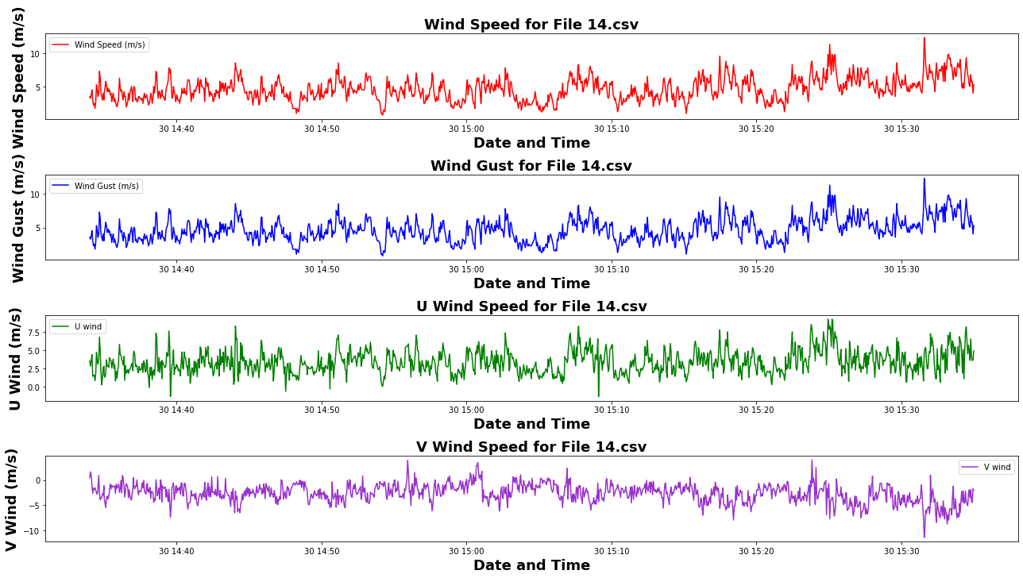

The code to produce this (and all the other anemometer) plot is called: anemometer_Plotting_Code_All_Files.py and it is located in: FireFlux2/FireFlux2-main/Codes/Anemometer_Codes/anemometer_Plotting_Code_All_Files.py

This code loops through all the anemometer files (they are all .csv files and all have their own numbers) and creates plots of them all. These plot the wind speed, wind gusts, U winds, and V winds. These plots are mainly just to see what the winds were like around the burn plot.

**Future steps**

My future steps on this project are to look at vertical velocities produced by the fire. Since there are a few levels of measurements, it would be interesting to see how much they change with height. Some other steps for the future are to look into the acceleration of the flow ahead of the fire front to see how fast it propagates, check if there are any fire induced winds, use a different fire spread model to see how that changes the rate of spread, and lastly, check how the fire progresses with time. By checking how the fire progresses with time, that will verify if all the wind data was inputted correctly, if the balbi model predicts the rate of spread properly, and if all other variables were inputted correctly and averaged properly. This will be done once I can run the model on WRF-SFIRE and view the output files.